A Project Report On

The Subjective Book Spot

# Submitted in Fulfillment for the Award of Degree

In

# DIPLOMA IN COMPUTER ENGINNERING

[Batch 2020 –2023]

# Submitted by

Khushal J. Pankhaniya [206030307114]

Dhruv C. Makadiya [206030307086]

Shrut D. Makadiya [206030307108]

# Under the Guidance of

Ms. Gemini A. Parmar

# Department Head

Mrs. Bhumika S. Zalavadia

# Submitted to

Atmiya Institute of Technology & Science for Diploma Studies

Gujarat Technological University

# Acknowledgement

Under the guidance of Ms. Gemini A. Parmar, we are able to bring our project to this state. We would also like to express our gratitude to ward sour other faculties and our HOD Mrs. Bhumika S. Zalavadiya for their kind co-operation and encouragement which helped using the completion of this project.

We are also thankful to the institution for giving us such an amazing opportunity for making this project and giving suitable instructions and guidelines for the project.

Last but not the least, we thank our friends who shared the necessary information and useful web links for preparing our project.

Thanks again to everyone.

# Team Member

|  |  |
| --- | --- |
| 1. Khushal J Pankhaniya | [206030307114] |
| 1. Dhruv C Makadiya | [206030307086] |
| 1. Shrut D Makadiya | [206030307108] |
|  |  |

**Abstract**

An online bookstore projects that acts as a central database containing various books in stock along with their title, author and cost. This project is a website that acts as a central book store. This web project is developed using PHP as the front end and SQL as a back-end. The SQL database stores various book related details. A user visiting the website can see a wide range of books arranged in respective categories. The user may select desired book and view its price. The user may even search for specific books on the website. Once the user selects a book, he then has to fill in a form and the book is booked for the user. The software has main components like implement of new user to register and login. Implement user to choose any book. Implement the user to buy books. The website will be implemented using PHP as the programming language .MYSQL database will be used to link database.

**Table of Content**

**Chapter: 1 Introduction Page number**

1.1 Project at Glance 6

1.2 Purpose 6

1.3 Scope 6

1.4 Technical Description 7

1.4.1 Front End 7

1.4.2 Back End 9

**Chapter: 2 System Analysis 10**

2.1 Study of Current System 11

2.2 Weakness of Current System 11

2.3 Introduction of New System 12

2.4 Hardware and Software Requirement 13

2.5 Project Model 14

2.6 Implementation Status 15

**Chapter: 3 System Design 16**

3.1 Use–case Diagram 17

3.2 Activity Diagram 20

3.3 Data Flow Diagram 25

3.4 Data Dictionary 27

3.5 Entity-Relationship (ER) Diagram 30

**Chapter: 4 Project Management 32**

4.1 Glimpse of Project 33

**Conclusion 50**

**Bibliography 51**

**CHAPTER 1**

**Introduction**

# 1.1 Project at Glance

# 1.2 Purpose

**1.3 Scope**

**1.4 Frontend and Backend**

Introduction

# 

# Project at Glance

* The main purpose of our web site is to create a subjective Book Store which can also provide different functionalities.
* The selected books are displayed in a tabular format and the user can order their books online through credit card payment or Case on delivery.
* Using this Website the user can purchase a book online instead of going out to a book store and wasting time. Online Book store is an online web application where the customer can purchase books online.
* Through a web browser the customers can search for a book by its title or author, later can add to the shopping cart and finally purchase using credit card ore case on delivery.
* The user can login using his account details or new customers can set up an account very quickly.
* The Online Book Store Website provides customers with online shopping through a web browser.
* A customer can, create, sign in to his account, place items into a shopping cart and purchase using his credit card details.
* The Master page, data sets, data grids, user controls are used to develop the Online Book store

# Purpose

* The main objective of the project is to create an online book store that allows users to search and purchase a book based on title, author and subject.
* The selected books are displayed in a tabular format and the user can order their books online through credit card payment.
* The Administrator will have additional functionalities when compared to the common user.
* Interest to develop a good user friendly website.
* To increase my knowledge horizon in technologies like SQL, CSS, and HTML.

# Scope

# It can associate with three users.

1. The main scope and deliverables of the project would be to:
2. •Understand and prepare detailed requirement and specifications
3. •Prepare high level and detailed design specifications of the system
4. •Prepare Test Plan and Test cases
5. •Develop the system and coding
6. •Perform unit testing, integration and system testing
7. •Demonstrate a bug free application after suitable modification if needed.
8. The main scope and deliverables of the project would be to:
9. •Understand and prepare detailed requirement and specifications
10. •Prepare high level and detailed design specifications of the system
11. •Prepare Test Plan and Test cases
12. •Develop the system and coding
13. •Perform unit testing, integration and system testing
14. •Demonstrate a bug free application after suitable modification if needed.
15. The main scope and deliverables of the project would be to:
16. •Understand and prepare detailed requirement and specifications
17. •Prepare high level and detailed design specifications of the system
18. •Prepare Test Plan and Test cases
19. •Develop the system and coding
20. •Perform unit testing, integration and system testing
21. •Demonstrate a bug free application after suitable modification if needed.

* User
* Admin

1. •Prepare high level and detailed design specifications of the system
2. •Prepare Test Plan and Test cases
3. •Develop the system and coding
4. •Perform unit testing, integration and system testing
5. •Demonstrate a bug free application after suitable modification if needed.

# 

# Introduction

# 1.4 Technical Description

## Front End

**HTML 5**

* HTML stands for Hyper Text Mark-up Language. It is used to design webpages using a mark-up language.
* HTMListhecombinationofHypertextandMark-uplanguage.Hypertextdefines the link between the web pages.
* This language is used to annotate (make notes for the computer) text so that a machine can understand it and manipulate text accordingly.
* Web Browser receives HTML documents from a web server or from local storage and rendersthedocumentsintomultimediawebpages.HTMLdescribesthestructureofawebpagesemanticallyandoriginallyincludedcues for the appearance of the document.

**Cascading Style Sheets (CSS)**

* A CSS Framework is a library allowing for easier, more standards-compliant web design using
* The Cascading Style Sheets language.
* Most of these frameworks contain at least a grid. More functional frameworks also come
* With more features and additional JavaScript-based functions, but are mostly design-oriented
* And focused around interactive UI patterns.
* This detail differentiates CSS frame works from other JavaScript frameworks.

**Font Awesome:**

* Font Awesome is a font and icon toolkit based on CSS and Less. It was made by Dave Gandy for use with Bootstrap and later was incorporated in to the Bootstrap CDN.
* FontAwesomehasa38%marketshareamongthosewebsitesthatusethird-partyfontscriptsontheir platform, ranking it second place after Google Fonts.

Introduction

**Java Script**

* JavaScript is a cross-platform, object-oriented scripting language used to
* Make webpages interactive.
* There are also more advanced server-side versions of JavaScript such as Node.js,
* Which allow you to add more functionality to a website than simply downloading
* Files (such as real time collaboration between multiple computers.)
* Inside a host environment (for example, a web browser), JavaScript can be connected to
* The objects of its environment to provide programmatic control over them.
* Client-side JavaScript extends the core language by supplying objects to control a
* Browser and its Document Object Model (DOM).
* Server-side JavaScript extends the core language by supplying objects relevant
* To running JavaScript on a server.

**Bootstrap**

* Bootstrap is an HTML, CSS, and JavaScript Framework and it is useful to
* develop responsive websites without rewriting the code for each device or
* Screen.
* If your code once, it just works for any browser, device, and screen.
* Bootstrap has not only HTML/CSS components but also JS components.
* With Bootstrap, you get to use common HTML elements but with a
* Beautiful representation of items.

## Introduction

## Back End

**SQLite:**

* DJANGO officially supports the SQLite Database.
* SQLite is are relational data base management system (RDBMS) contained in a C library.
* Serverdatabaseengine. Rather, it is embedded in the end program.
* SQL it is ACID-compliant and implements most of the SQL standard, generally following Post SQL syntax.
* However, SQ Lite use dynamically- and weakly-typed SQL syntax that does not guarantee the domain integrity.

**Php:**

* (PHP: Hypertext Preprocessor) An extremely popular scripting language that is used to create dynamic Web pages. Combining syntax from the C, Java and Perl languages.
* PHP code is embedded within HTML pages for server side execution.
* It is commonly used to extract data out of a database on the Web server and present it on the Web page. Originally known as "Personal Home Page,
* PHP is supported by all Web servers and widely used with the MySQL database.

System Analysis

**Chapter: 2**

**System Analysis**

**2.1 Study of Current System**

**2.2** **Weakness of Current System**

**2.3 Introduction of New System**

**2.4** **Hardware and Software Requirement**

**2.5** **Project Model****Implementation Status**

System Analysis

# Study of Current System

* Nowadays, the network plays an import role in people’s life.
* In the process of the improvement of the people’s living standard, people’s demands of the life’s quality and efficiency is more higher
* The traditional bookstore’s inconvenience gradually emerge, and the online bookstore has gradually be used in public.
* The online bookstore is a revolution of book industry.
* The traditional bookstores’ operation time, address and space is limited,
* So the types of books and books to find received a degree of restriction.
* But the online bookstore broke the management mode of traditional bookstore, as long as you have a computer, you can buy the book anywhere, saving time and effort,
* Shortening the time of book selection link effectively.
* The online bookstore system based on the principle of provides convenience and service to people.

# Weakness of Current System

* Online Book Store is a specific requirement of the client that integrates the buying and selling services specifically to their customers.
* Reports can be generated at any time within few seconds, so that labor is not required, and also analysis can be performed much more frequently which helps in taking decision.
* The details regarding all users, books can also be maintained as their information is very helpful and sometimes becomes a critical requirement.
* Allows user to get registered from their places and transact for the required product.
* To overcome these problems we develop “Online Book Store”.

System Analysis

# Introduction to New System

* Online shop in is the process whereby consumers directly buy goods, services etc.from a seller interactively in real-time without an intermediary service over the internet
* An online bookstore projects that acts as a central database containing various books in stock along with their title and cost.
* Also user can search book.
* The Administrator will have additional functionalities when compared to the common user.
* This project is a website that acts as a central book store. This web project is developed using PHP as the front end and SQL as a back-end.
* The SQL database stores various book related details.
* A user visiting the website can see a wide range of books arranged in respective categories.
* The user may select desired book and view its price.
* The user may even search for specific books on the website. Once the user selects a book, he then has to fill in a form and the book is booked for the user.
* The software has the following three main components:-
* Implement of new user to register and login.
* Implement user to choose any book
* Implement the user to buy books.
* Interest to develop a good user friendly website with many online transactions using a database
* To increase my knowledge horizon in technologies like SQL, CSS, HTML.

System Analysis

# 2.4 Hardware and Software Requirement

## Hardware

Processor:Core RAM: 128 MB

Storage: 20 GB or above

## Software:

OS: Windows 7 and MacOS10.5.8

Browser:

* Firefox
* Chrome
* Safari5.0.6

# Project Model

* A project model is a clear and visual description of how a project should be brought off.
* Some project model customized for a specific industry, as specific kind of project, or even for as specific project.
* In the project model, the flow of the project is described.

## Iterative Model:

* It executes one or more activities repetitively to get accuracy before starting the next activity.
* As we use the Iterative Model, the features released to the end-users may altered in a phase-wise manner and new features can be released and implemented based on the feedback. Similarly, the feedback from each stage would also modify the product features.

System Analysis

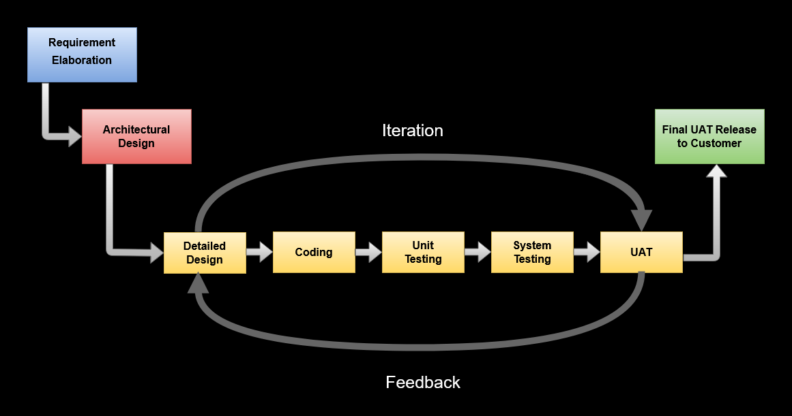

**2.5 Iterative Model**

## Consider an iterative life cycle model which consists of repeating the following five phases in sequence:

* + - **Requirement Elaboration Phase:** EVRY’s team reviews the current requirements document thoroughly with the client and validates the same. In some cases, the team jointly works towards expanding on the requirements or revising them to obtain better clarity.
    - **High-Level Design Phase:** The design aspects of the application are completed in the High-Level Design Phase, which includes Software Design Architecture, Logical Database Design, Proto type Concept of Design, and Test Strategy.

System Analysis

* + - **Development Phase:** This phase is based on the approved requirements from theRequirementElaborationPhaseandadesignfrozenintheHigh-LevelDesignPhase.Itincludeslow-leveldesign, user interface, coding, unit testing, integration, and system testing. EVRY prefers to follow shorter development and testing cycles, and provide working deliverable sas opposed to sing long cycle and a final deliverable.
    - **Final UAT Phase:** UAT means User acceptance testing. In this final phase, the application will be released and the client will test the application to ascertain that allthefeaturesareworkingasdefinedintherequirementsdocument.Anyissuesreported are fixed and other enhancements provided are considered as a 'Change Request'.

# 2.6 Implementation Status

# Chapter: 3

# System Design

**3.1 Use – case Diagram**

**3.2 Activity Diagram**

**3.3 Data Flow Diagram**

**3.4 Data Dictionary**

**3.5 Entity-Relationship (ER) Diagram**

# Use case Diagram

* it describes the sequence of interactions between actors and the system necessary

To deliver the service that satisfied the goal.

* The use case diagram graphically represents whathappensifanyactorisinteracting with system.
* It show relationships and dependencies clearly in the diagram.
* The main purpose of the diagram is to identify requirements.
* It summarizes some of the relationships between use cases.

## System:

Draw your system's boundaries using rectangle that contains use cases. Place actors outside the system's boundaries.



## Use Case:

Drawusecasesusingovals.Labeltheovalswithverbsthatrepresentthesystem'sfunctions.



## Actors:

Actorsaretheusersofasystem.Whenonesystemistheactorofanothersystem, label theactorsystem with the actorstereotype.



## Relationships:

Illustrate relationships between an actor and a use case with a simple line. For relationship samongu se ases, "uses "or" extends.” A "uses" relationship in d Cates that one use case is needed by another in order to perform a task. An "extends" relationship indicates alternative options under a certain use case.

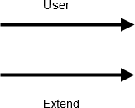

Admin

User

**3.1 Use Case Diagram**

# Activity Diagram

* + - Activity diagram are a kind of behavior diagram. Activity diagrams are often used in business process modelling. They can also describe the steps in a use case diagram.

## Initial State or Start Point:

**Start:**

A small filled circle followed by an arrow represents the initial action state or the start point for any activity diagram. For activity diagram using swim lanes, make sure the start point is placed in the top left corner of the first column.



## ActivityorActionState:

An action state represents the non-interruptible action of objects. You can draw an action state in Smart Draw using a rectangle with rounded corners.



## Action Flow:

Action flows, also called edges and paths, illustrate the transitions from one action state to another. They are usually drawn with an arrowed line.



## Decisions and Branching:

A diamond represents a decision with alternate paths. When an activity requires a decision prior to moving on to the next activity, add a diamond between the two activities. The outgoing alternates should be labelled with a condition or guard expression. You can also

Label one of the paths "else."

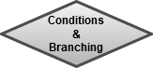

## Final State or End Point:

An arrow pointing to a filled circle nested inside another circle represents the final action state.



Sign in

Check

Item not found

Visit FAQ

Login

View detail

Book add to cart

Check

No

Yes

Payment

Order detail summary

Sign out

Sign out

Sign out

Sign out

Sign out

Sign out

.**3.2 Activity Diagram**

# Admin:

Sign up

Log in

Manage order

Add book

Read message

Remove book

Log out

.**3.3 Activity Diagram**

* + - **User:**

Sign up

Log in

Visit website

Search book

Add to Card

Placing order

Log out

.**3.4 Activity Diagram**

# Data Flow Diagram

* A data flow diagram show show data is processedbyasystemintermsofinputsandoutputs.
* As its name indicates itsfocusisonthe flow of information, where data comesfrom,where it goes and how it gets stored.
* DFDcanshowhowdifferentdepartmentsof theorganizationcooperate.
* Data Flow Diagram is designed to answer the question “how it works?”
* All the processes in the DFD must be linked to either another process or a data store.
* Eachdatastoreandtheprocessmusthaveaminimumofonedataflowgoingintoitandonedataflowleavingit.
* Ata store must go through a process.

Online book

Store

User

Admin

Search for book modify book

Buy book login management

Payment

Login



**Level-0**

User

Admin

**N**o No

conditon

Sign up

conditon

Sign up

yes yes

Log in

Log in

Add to cart

Read message

Search book

Add/remove book

Manage order

Place order

**Level 1**

**Data flow diagram level 1:**

* **Level 1 DFDs** are still a general overview, but they go into more detail than a context diagram.
* In level 1 DFD, the single process node from the context diagram is broken down into sub-processes. As these processes are added,
* The diagram will need additional data flows and data stores to link them together. In the hotel reservation example,
* This can include adding the room selection and inquiry processes to the reservation system, as well as data stores.
  1. **Data Dictionary**
* A Data Dictionary is a collection of names, definitions, and attributes about dataelementsthatarebeingusedorcapturedinadatabase,informationsystem,orpartofa research project. It describes the meanings and purposes of data elements within the context of a project and provides guidance on interpretation, accepted meanings, and representation.
* A Data Diction also provides metadata. Metadata is data about data.

There are two type of data dictionary:

1. Active data dictionary: It is managed automatically by the database management system.
2. Passive data dictionary: It managed users of the system.

**User:**

|  |  |  |  |  |
| --- | --- | --- | --- | --- |
| **id** | **name** | **email** | **password** | **user type** |
| 7 | sager | hh@gmail.com | 698d51a19d8a121ce581499d7b701668 | user |
| 9 | Khushal | khushal5@gmail.com | 3948ead63a9f2944218de038d8934305 | admin |
| 10 | Dhruv | dhruv@gmail.com | 15de21c670ae7c3f6f3f1f37029303c9 | user |

# Products:

|  |  |  |  |
| --- | --- | --- | --- |
| **id** | **name** | **price** | **image** |
| 3 | java | 190 | 514axA2lwpL.jpg |
| 4 | Php | 200 | 512su9kPPtL._SX391_BO1,204,203,200_.jpg |
| 5 | c++ | 150 | WhatsApp_Image_2021-03-16_at_12.57.08-thumbnail-540x540-70.jpeg |
| 6 | javascript | 250 | cover.jpg |

# Orders:

|  |  |  |  |  |  |  |  |  |
| --- | --- | --- | --- | --- | --- | --- | --- | --- |
| **name** | **number** | **email** | **method** | **address** | **products** | **total price** | **place on** | **payment status** |
| Khushal | 122 | dhruv@gmail.com | credit card | flat no. 2, c, hht, cd - 4 | , be well bee (1) | 10 | 15-Nov-22 | completed |
| Shrut | 65103008532 | shrut@gmail.com | cash on delivery | flat no. 3, A3, Rajkot, India - 123456 | , Php (1) , c language (1) , javascript (1) | 690 | 17-Nov-22 | pending |

**Content us:**

|  |  |  |  |  |  |
| --- | --- | --- | --- | --- | --- |
| **id** | **user id** | **name** | **Email** | **number** | **message** |
| 1 | 10 | Dhruv | dhruv@gmail.com | 1 | This is best project |
| 2 | 10 | Dhruv | dhruv@gmail.com | 555 | this is best project in atmiya college |
| 3 | 10 | Khushal | khushal@gmail.com | 4454565 | please send order fast |

**ER Diagram:**

* **An Entity Relationship (ER) Diagram is type off Low chart that illustrate show “entities”**

**Such as people, objects or concepts relate to each other within a system.**

* **ER Diagrams are most often used to design or debug relational databases in the**

**Fields of software engineering, business information systems, education and**

**Research.**

* **Also known as ERDs or ER Models, they use a defined set of symbols such as**

**Rectangles, diamonds, ovals and connecting lines to depict the inter connectedness**

**Of entities, relationships and their attributes**

**Uses of entity-relationship diagrams:**

1. Database design
2. Database troubleshooting
3. Business information systems
4. Business process-engineering(BPR)
5. Education
6. Research.

manage

visit

Send message

Has

Has

**Admin**

**Contact**

**Order**

**Product**

**User**

**Online book store**

**Chapter: 4**

**Project Management**

# 4.1 Glimpse of Project:

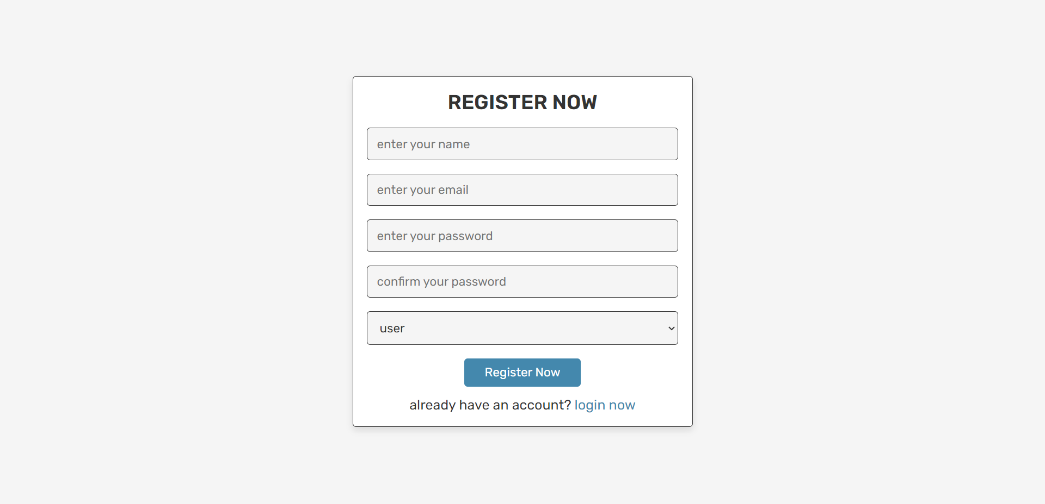

**Windows: Register**

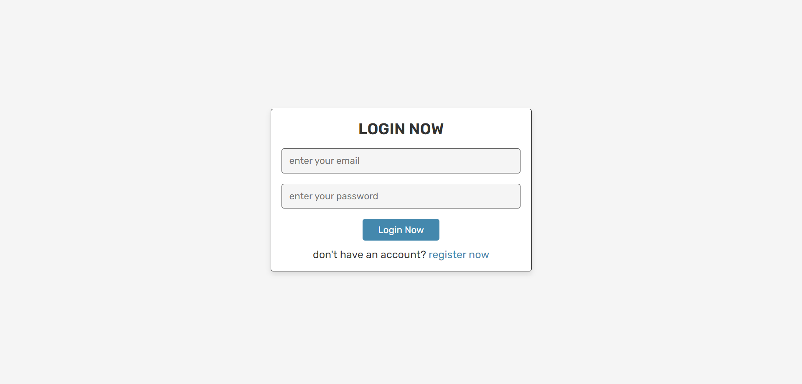

**Windows: Sign up**

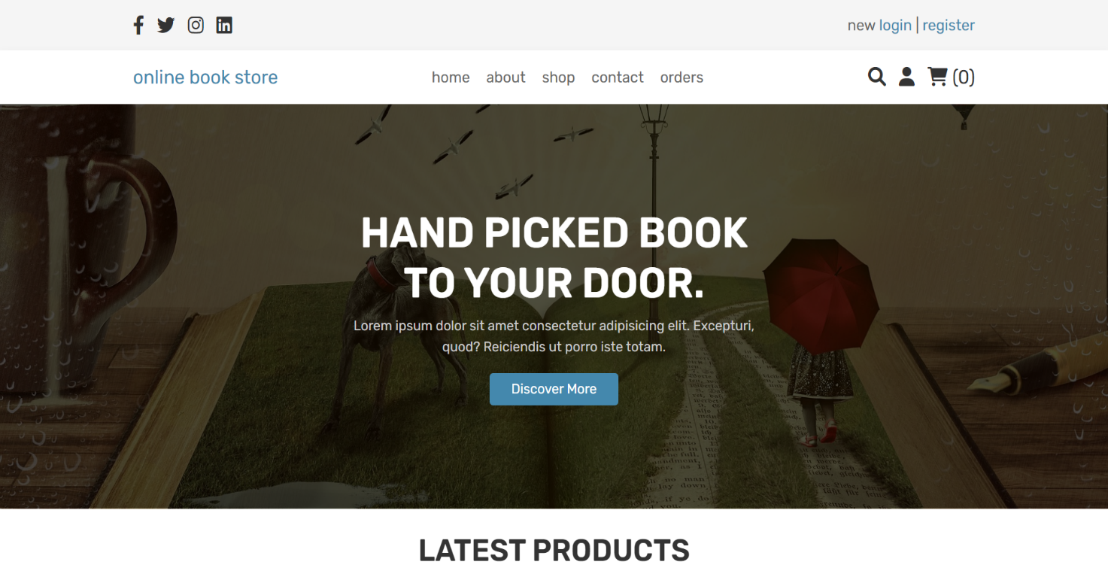

**Windows: home**

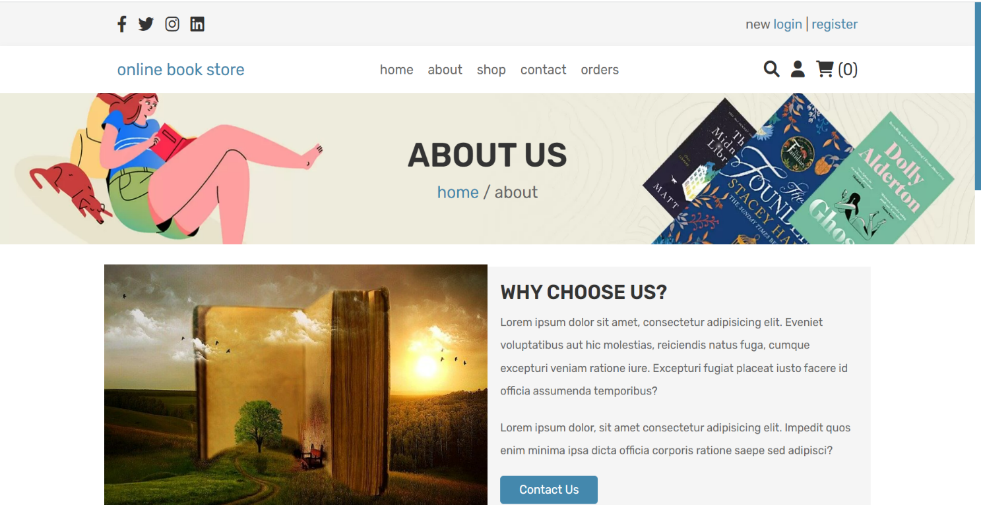

**Windows: about**

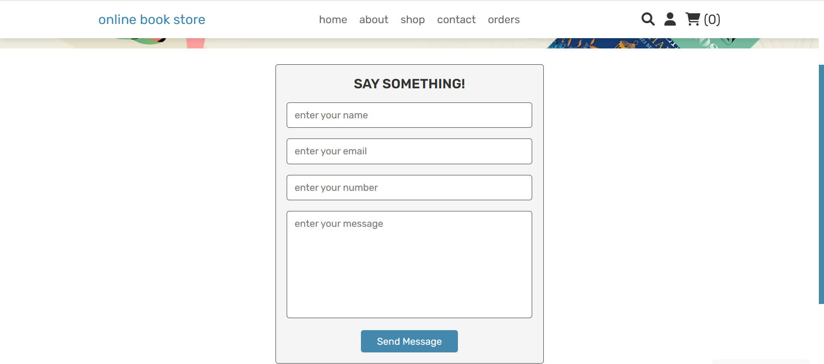

**Windows: contact**

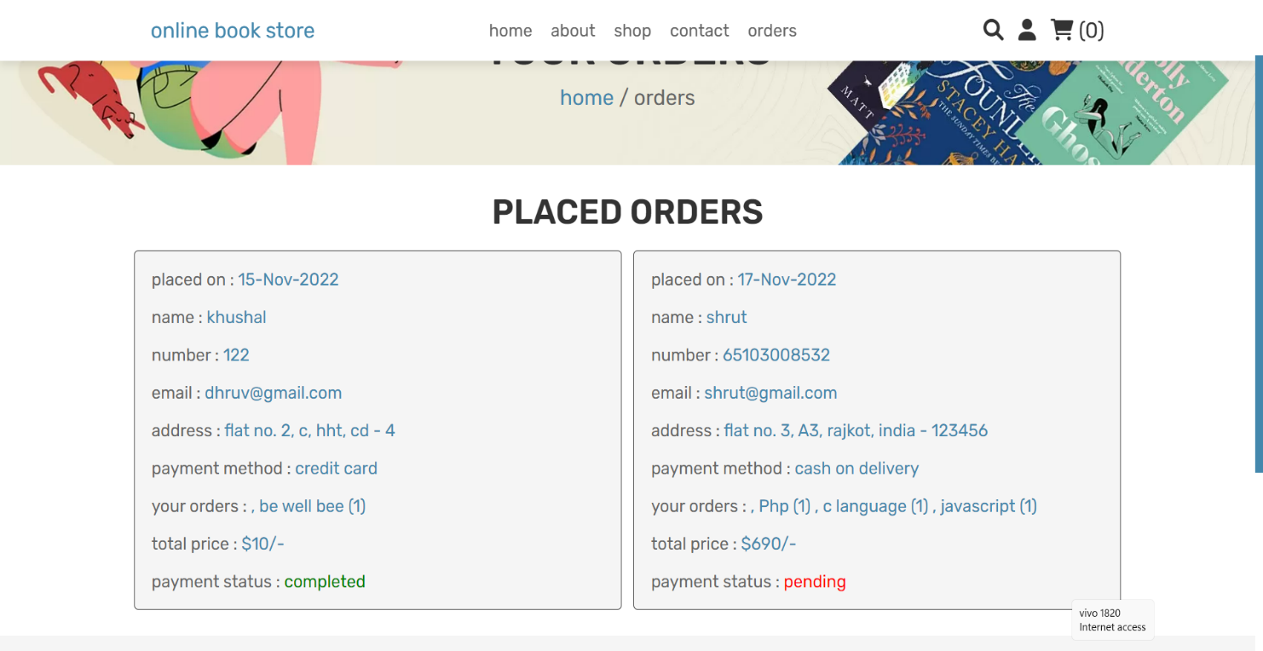

**Windows: orders**

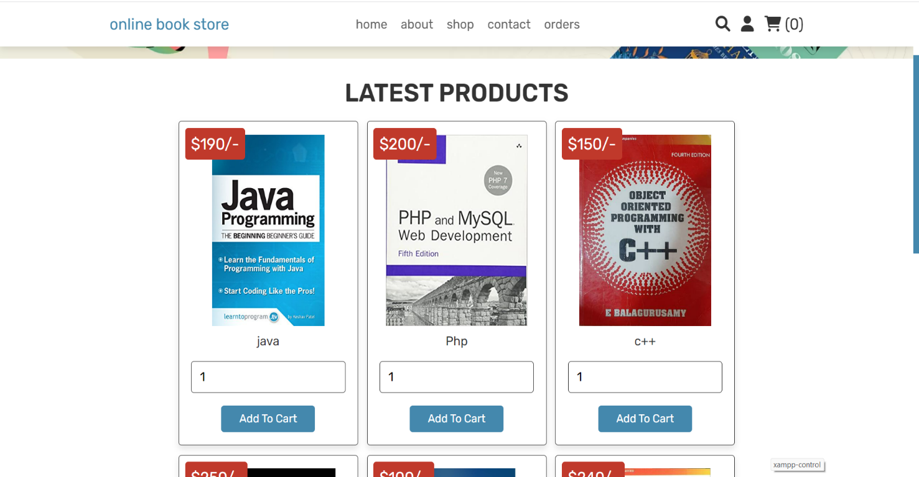

**Windows: Shop**

**Admin panel**

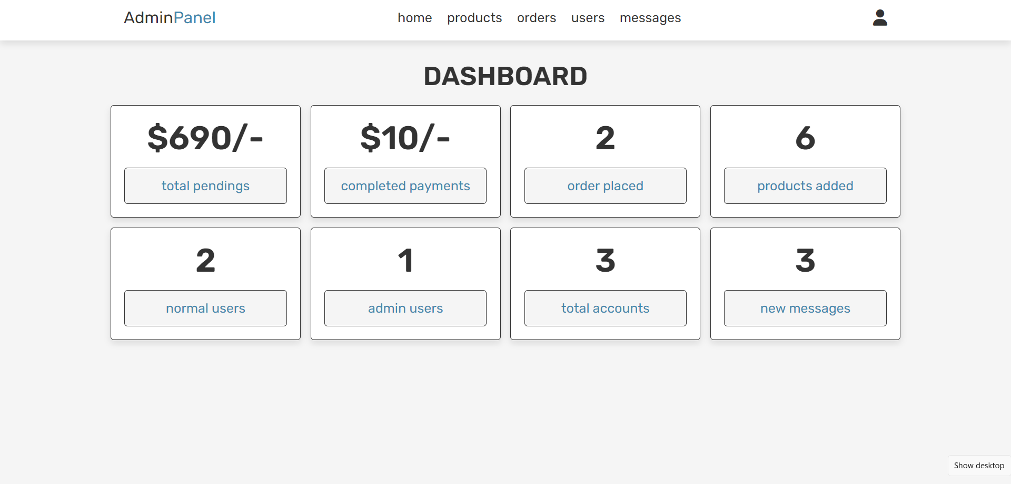

**Windows: home**

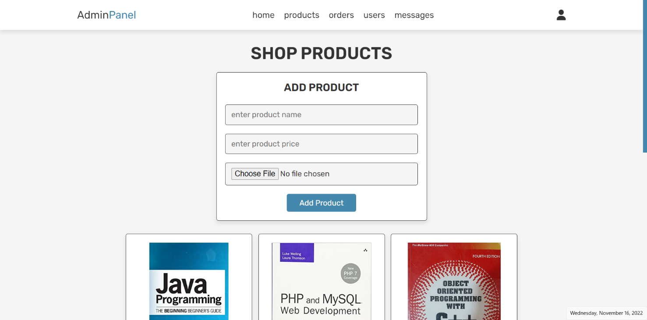

**Windows: Products**

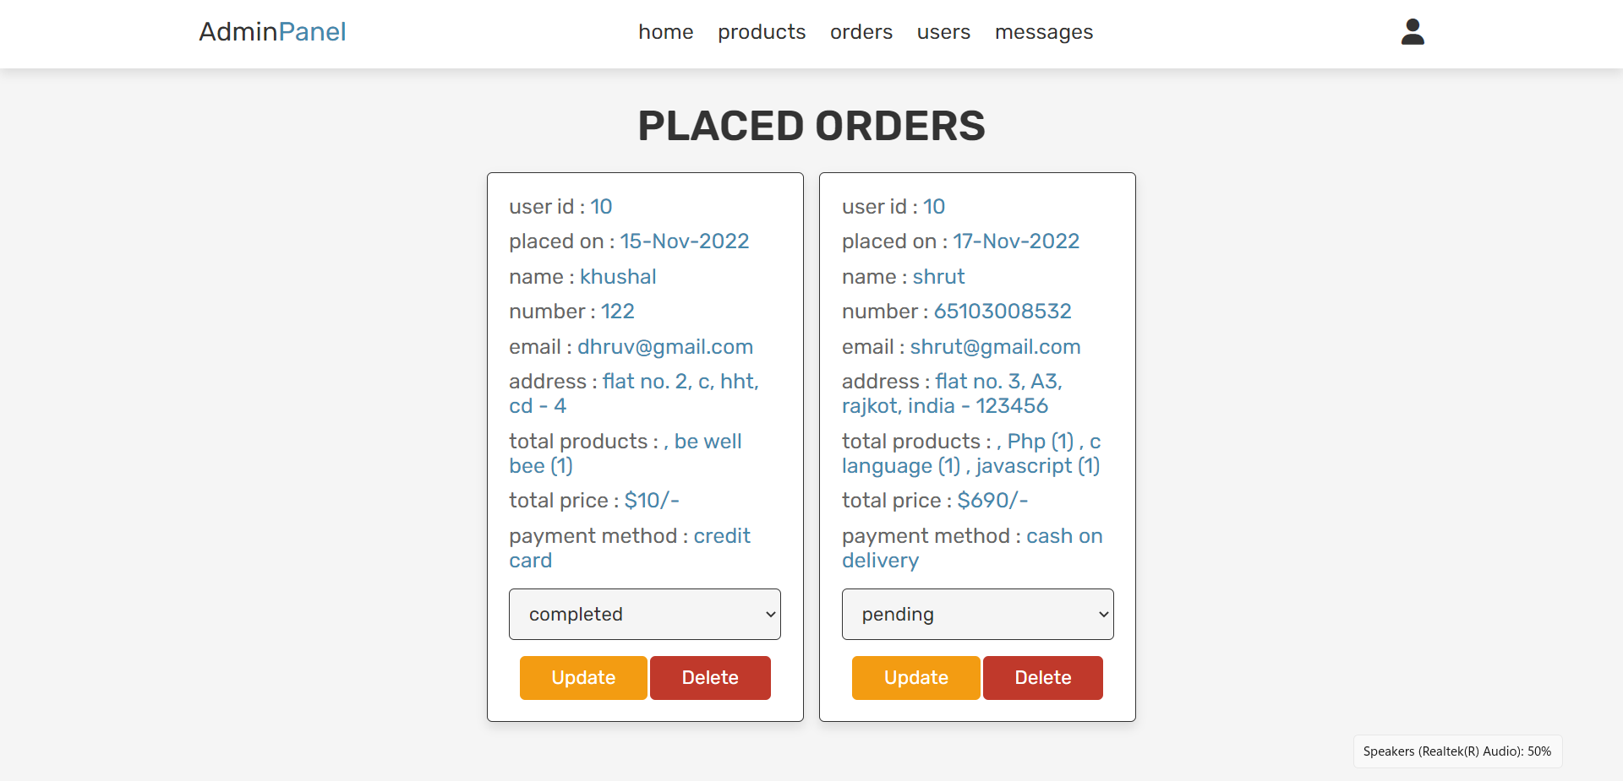

**Windows: Orders**

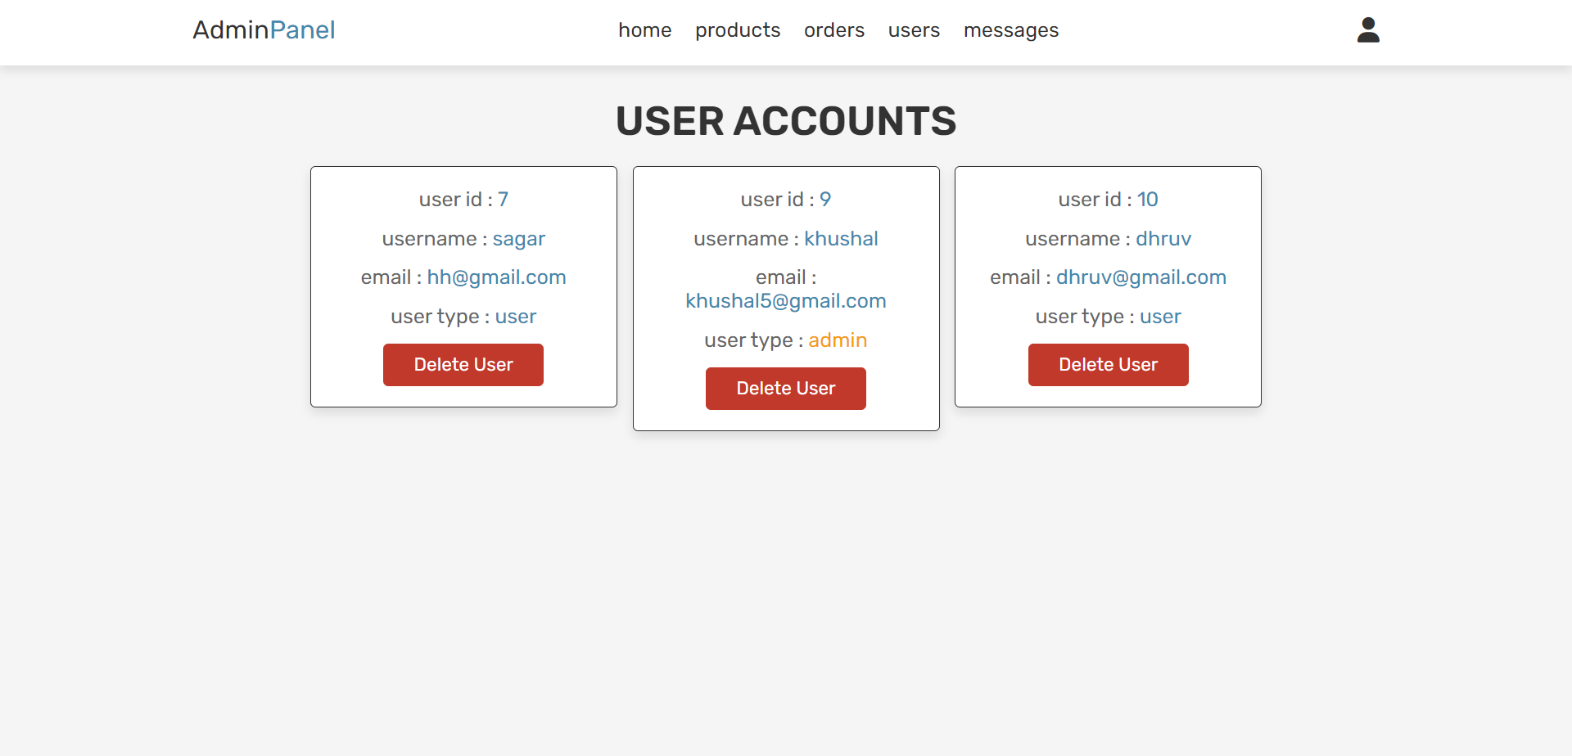**Windows: Users**

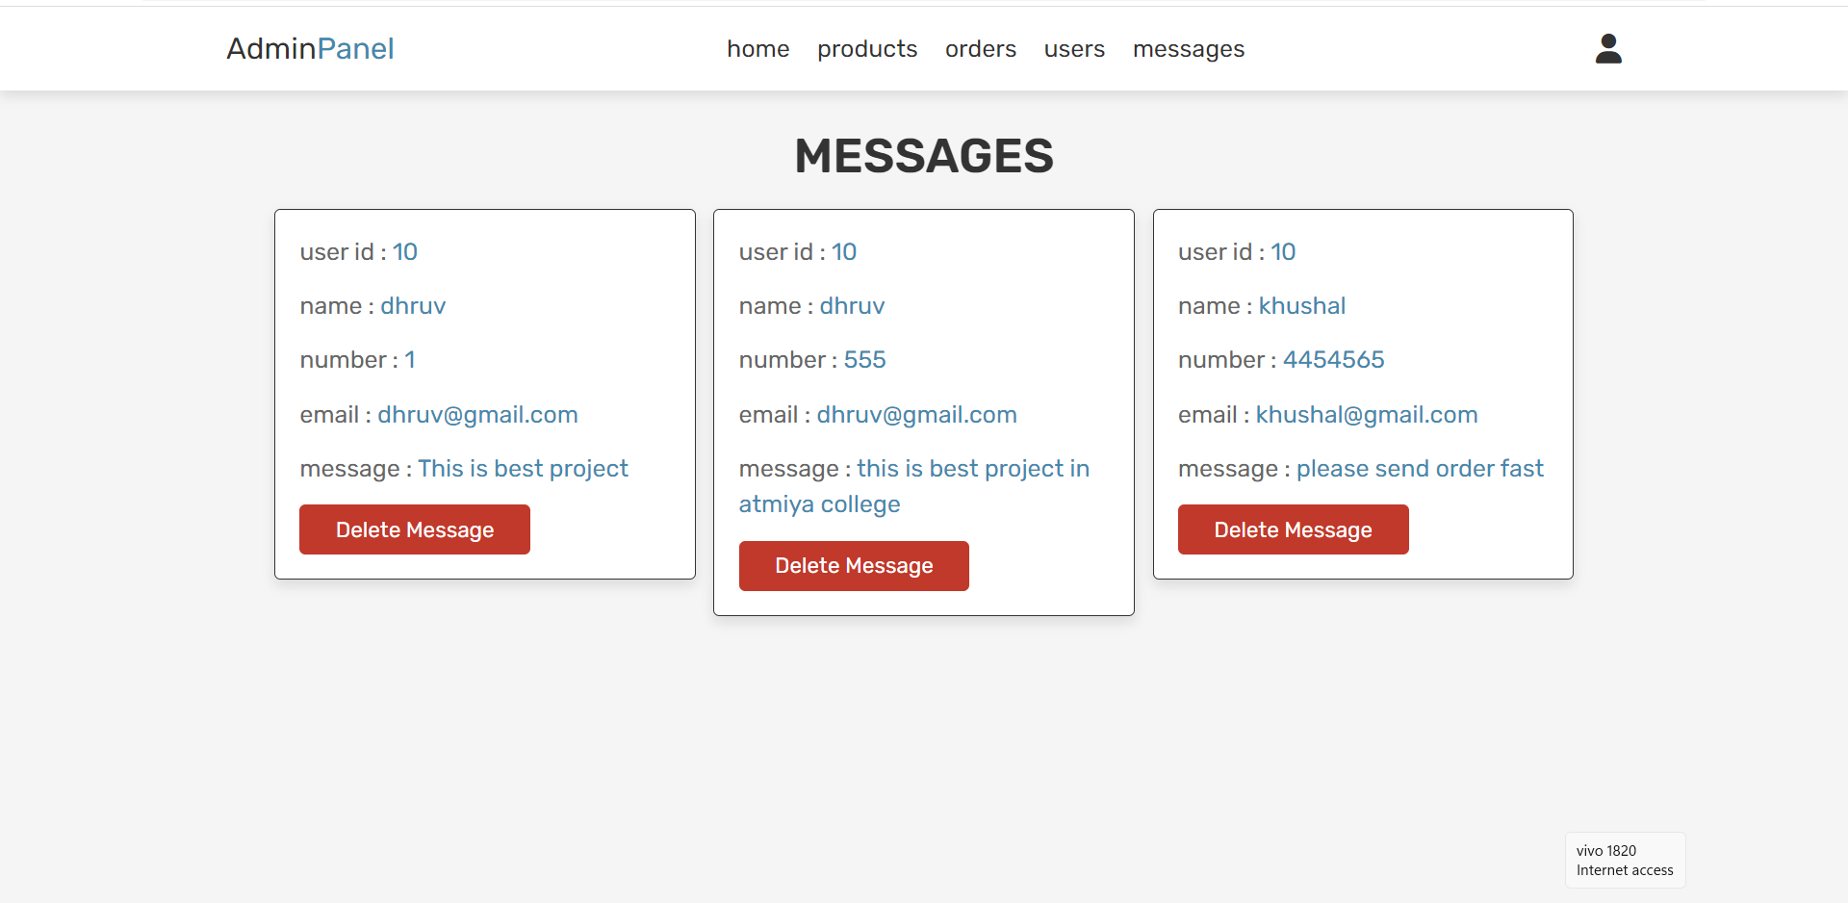

**Windows: Messages**

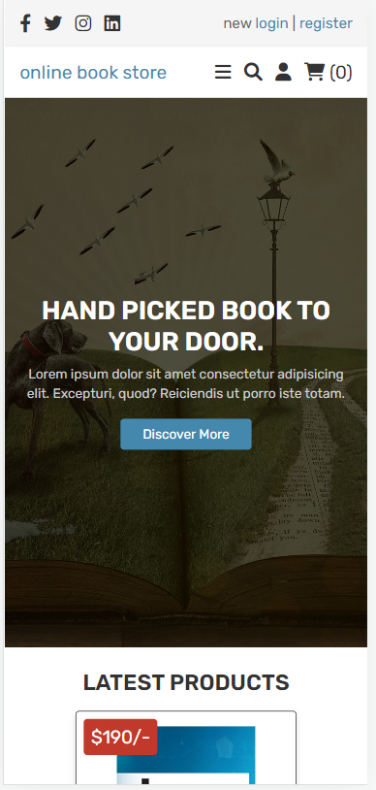

**Mobile: Home**

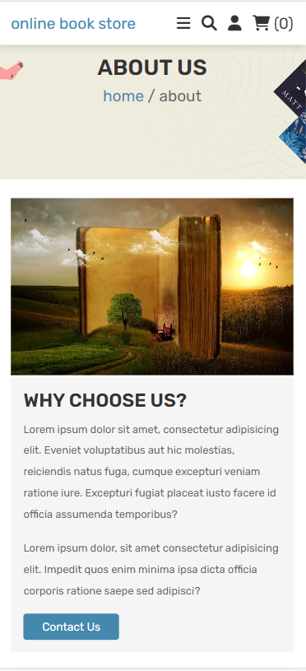

**Mobile: About**

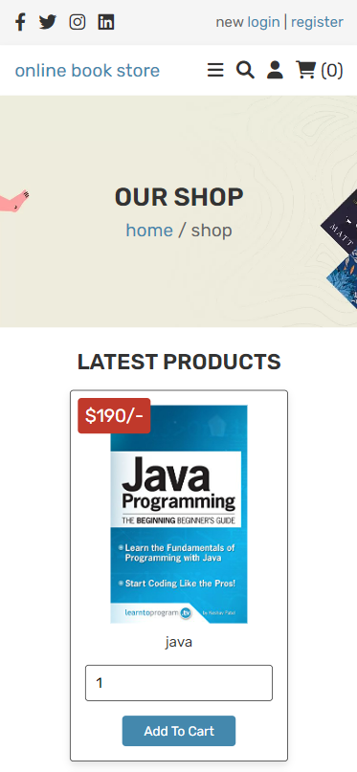

**Mobile: Shop**

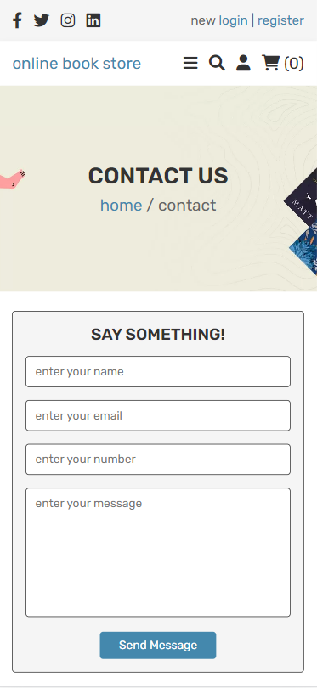

**Mobile: Contact**

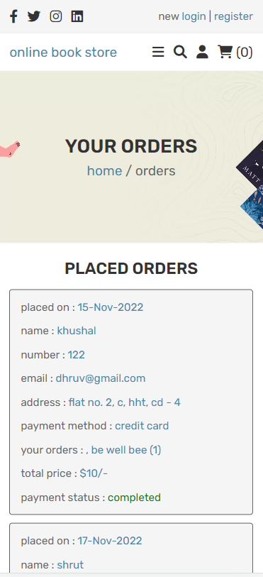

**Mobile: Orders**

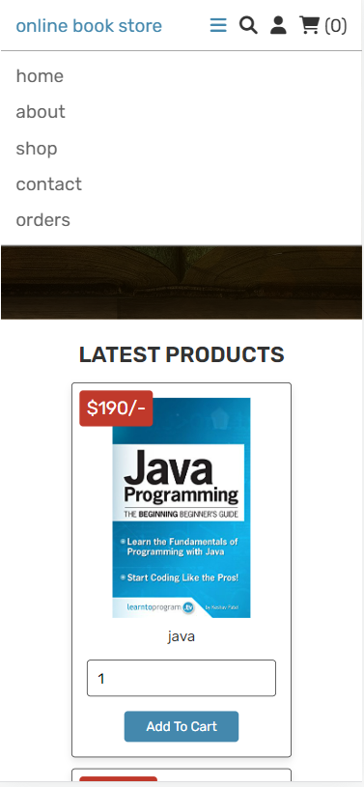

**Mobile: Navbar**

**Mobile: Admin panel**

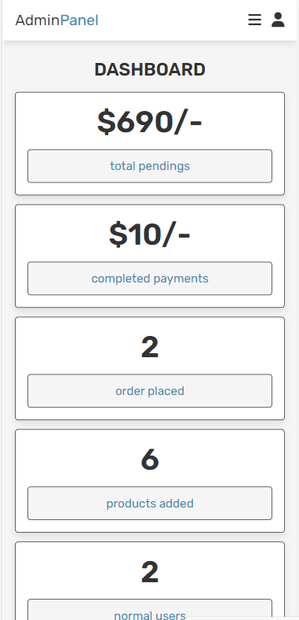

**Mobile: home**

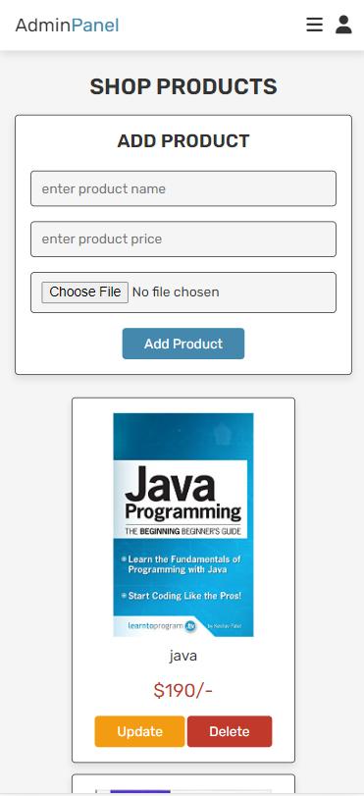

**Mobile: Product**

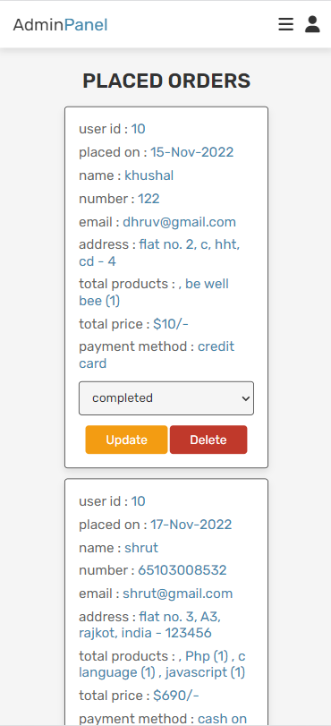

**Mobile: Orders**

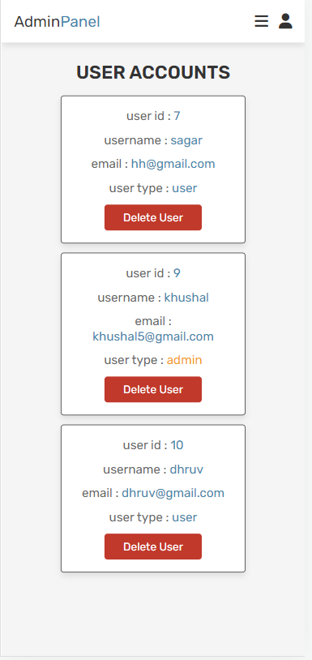

**Mobile: Account**

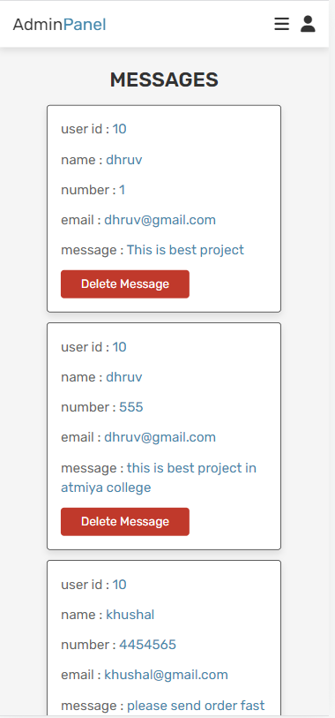

**Mobile: Message**

**Conclusions**

Online shopping is the process of buying goods and services from merchants who sell

on the Internet. Since the emergence of the World Wide Web, merchants have sought to sell

their books to people who surf the Internet. Shoppers can visit web stores from the comfort of

their homes and shop as they sit in front of the computer. Consumers buy a variety of items

from online stores. In fact, people can purchase just about anything from companies that

provide their books online.

Online shopping is the process of buying goods and services from merchants who sell

on the Internet. Since the emergence of the World Wide Web, merchants have sought to sell

their books to people who surf the Internet. Shoppers can visit web stores from the comfort of

their homes and shop as they sit in front of the computer. Consumers buy a variety of items

from online stores. In fact, people can purchase just about anything from companies that

provide their books online.

Online Book store is an online web application where the customer can purchase books online. Through a web browser the customers can search for a book later can add to the shopping cart and finally purchase using credit card transaction. This **Online Book Store Project in php.** The Online Book Store System is a simple project similar like shopping cart or ecommerce but is only for book shopping. Categories wise books available its very good project for Final Year student academic Purpose. This project built with php framework and it's allows users to search and purchase book online.

**Bibliography**

# Web Site

[**www.amazon.com**](http://www.amazon.com)

[**www.bookswagon.com**](http://www.bookswagon.com)

[**www.kitaboo.com**](http://www.kitaboo.com)